SDA LAB 4

Laiba Fatima 22k-5195

Task 1:

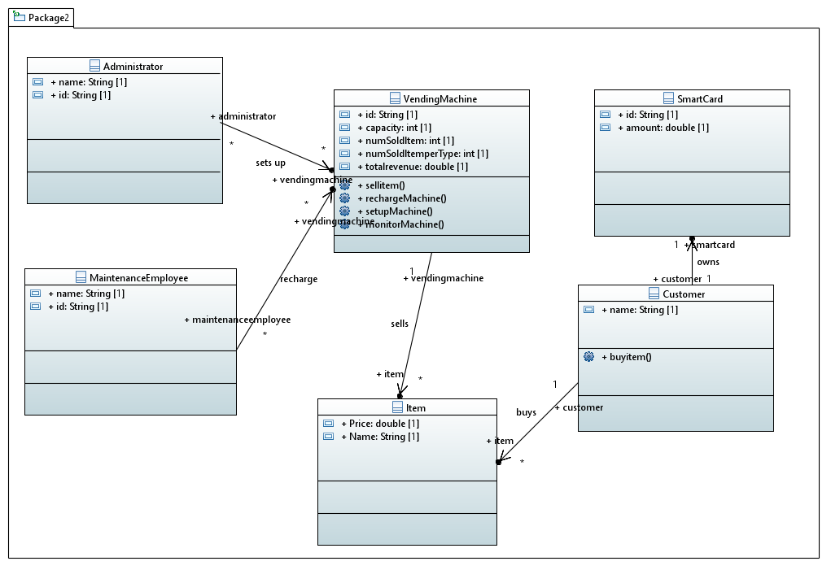

**package** Package2;

**import** java.util.List;

**public** **class** Administrator {

/**

*

*/

**public** String name;

/**

*

*/

**public** String id;

/**

*

*/

}

**public** **class** Customer {

/**

*

*/

**public** String name;

/**

*

*/

**public** List<Item> item;

**public** SmartCard smartcard;

/**

*

*/

**public** **void** buyitem() {

// **TODO** Auto-generated method

}

}

**public** **class** Item {

/**

*

*/

**public int** Price;

/**

*

*/

**public** String Name;

/**

*

*/

}

**public** **class** SmartCard {

/**

*

*/

**public** String id;

/**

* Getter of ID

*/

**public** String getID() {

**return** id;

}

/**

*

*/

}

**public** **class** VendingMachine {

/**

*

*/

**public** List<MaintenanceEmployee> maintenance;

/**

*

*/

**public** **int** numSoldItemperType;

/**

*

*/

**public** **double** capacity;

/**

*

*/

**public** List<Administrator> administrator;

/**

*

*/

**public** List<Item> item;

/**

*

*/

**public** String id;

/**

*

*/

**public** **double** totalrevenue;

**public** **int** NumSoldItem;

**public** **void** sellitem() {

// **TODO** Auto-generated method

}

**public** **void** rechargeMachine() {

// **TODO** Auto-generated method

}

**public** **void** setupMachine () {

// **TODO** Auto-generated method

}

**public** **void** monitorMachine () {

// **TODO** Auto-generated method

}

}

**public** **class** MaintenanceEmployee {

/**

*

*/

**public** String ID;

/**

*

*/

**public** String Name;

/**

*

*/

}

Task 2:

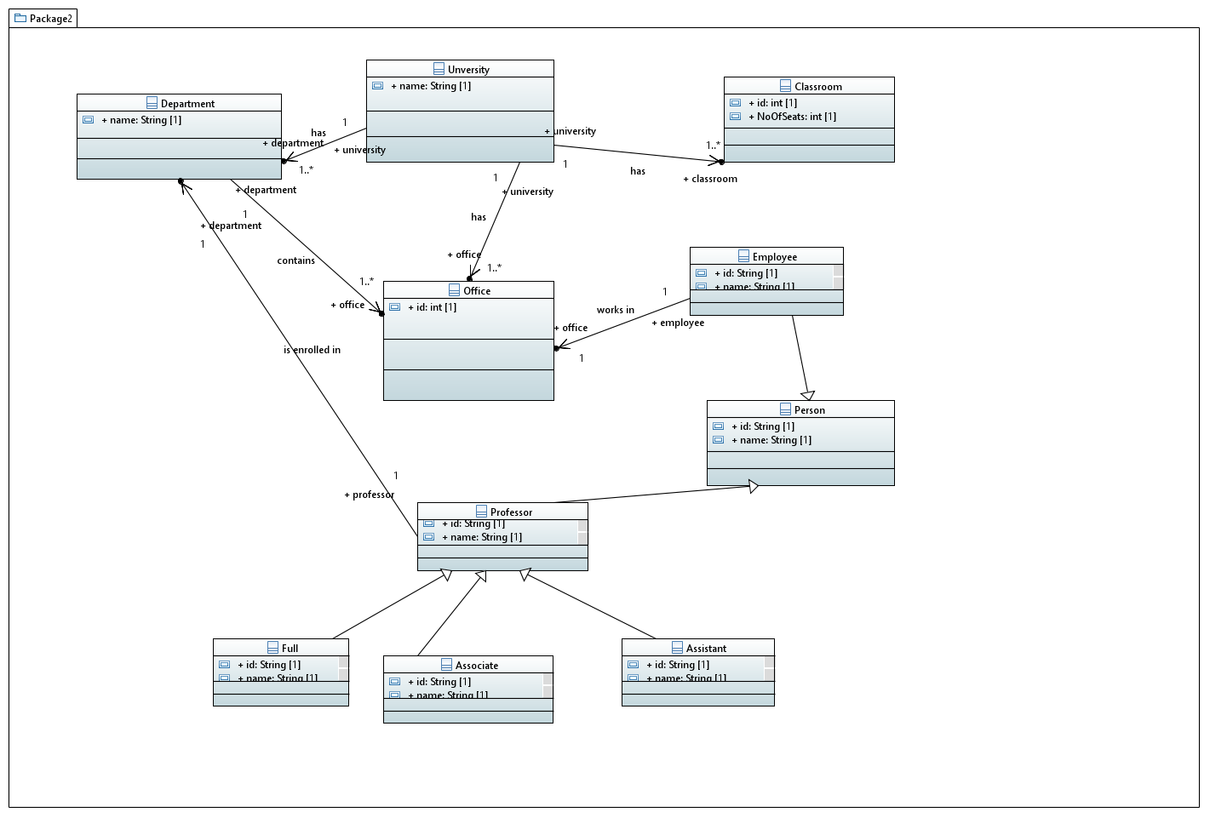

Task 3:

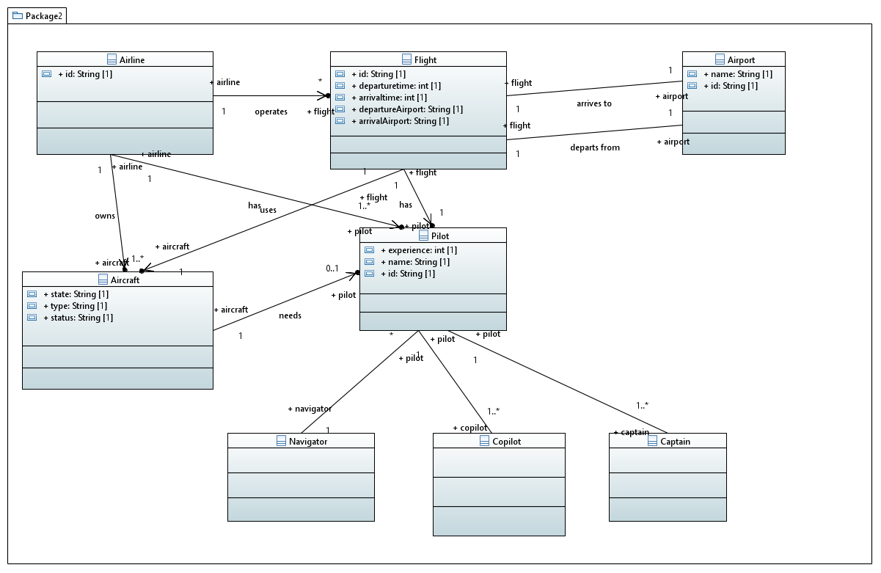

Task 4:

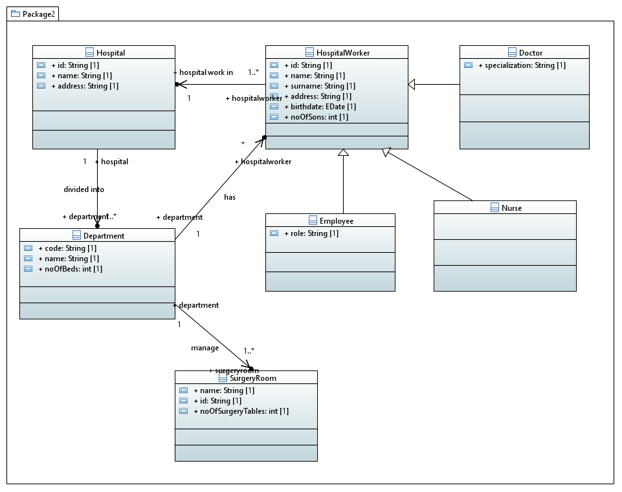

Task 5:

